# **Capstone Project: Data Visualization Tools**

**Create Stunning Tableau Desktop/Tableau Public/PowerBI Dashboard from the same dataset on which EDA was performed for the capstone project.**

Suppose, **if someone performed EDA on Airbnb operations** then the following steps need to be followed for building an adequate dashboard through which one can analyse the performance of the company to take necessary actions.

**Dataset Details:**

* Dataset Name: Airbnb Listings Data
* Source: [Link to dataset](http://insideairbnb.com/get-the-data/)
* Cities: Chicago & New Orleans
* Description: The Airbnb Listings Data contains information about different properties available for rent on Airbnb in a specific city. Each record represents a unique listing and includes attributes such as property type, neighbourhood, number of bedrooms, pricing, availability, host information, and more.

**Key Attributes**:

* id: Unique identifier for each listing.
* name: The title or name of the listing.
* host_id: Unique identifier for the host of the property.
* host_name: Name of the host.
* neighbourhood_group: The broader area or group that the neighbourhood belongs to.
* neighbourhood: Specific neighbourhood where the property is located.
* latitude: Latitude coordinate of the property.
* longitude: Longitude coordinate of the property.
* room_type: Type of room (e.g., Private room, Entire home/apt, Shared room).
* price: Price of the listing per night.
* minimum_nights: Minimum number of nights required for booking.
* number_of_reviews: Total number of reviews received for the listing.
* last_review: Date of the last review.
* reviews_per_month: Average number of reviews per month.
* availability_365: Number of days the listing is available for booking in a year.

1. Which are the popular neighbourhoods, their average prices and no. of listings?

Ans. Top 10 popular neighbourhood, avg. Price. No. Of listings

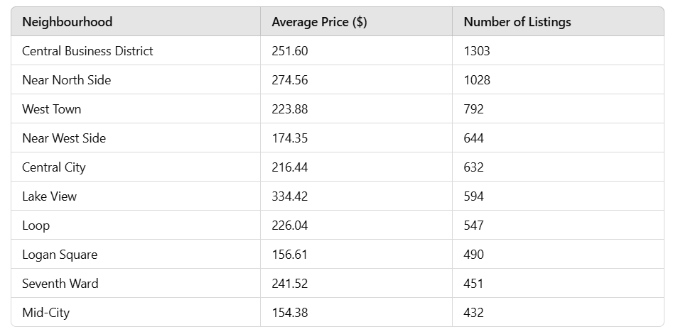

1. What is the percent share of different property types and room types?

Ans. Percent Share of Room Types:

1. **Entire home/apartment** → **80.75%**
2. **Private room** → **16.91%**
3. **Hotel room** → **1.60%**
4. **Shared room** → **0.75%**

3.How the pricing is varying with location, property type, and reviews?

Ans.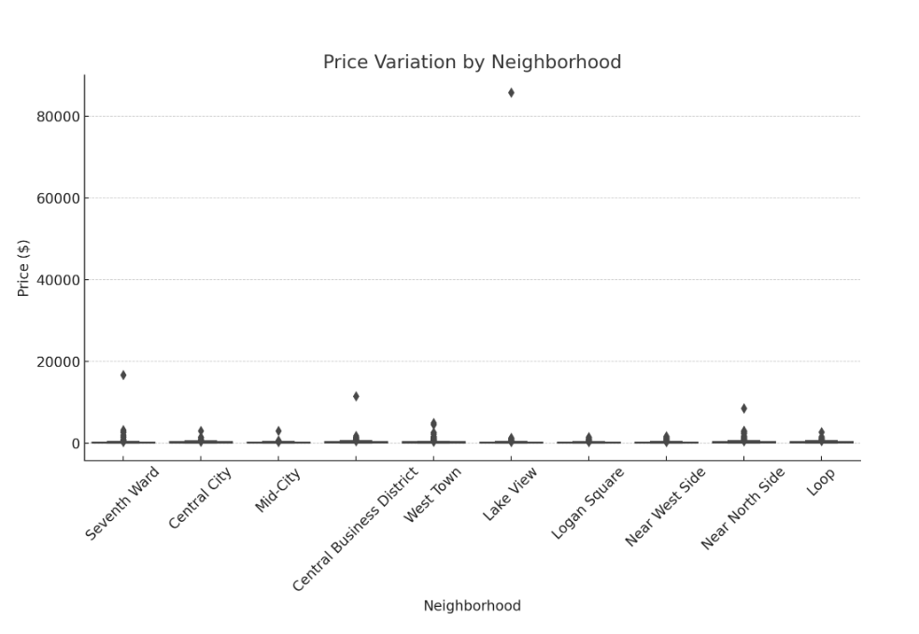

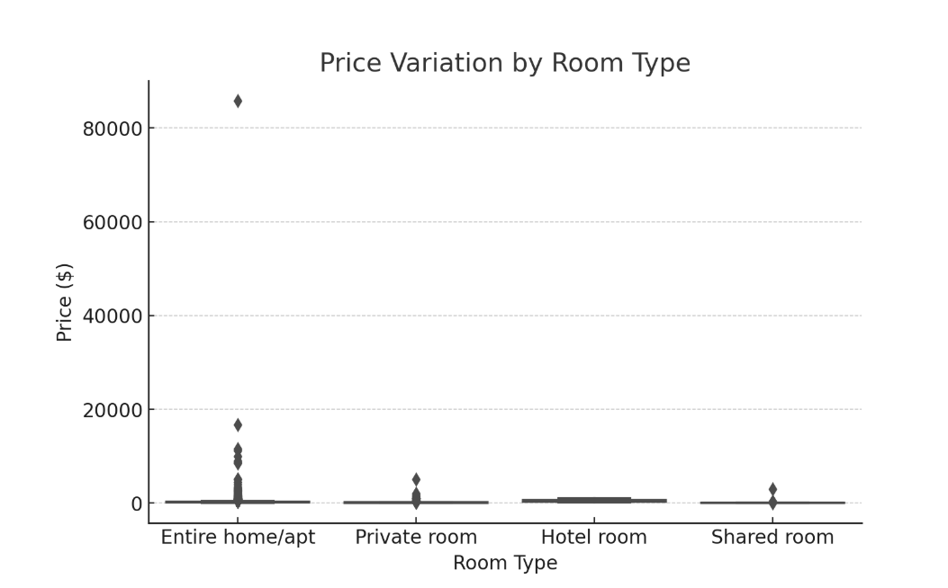

4.What are the different correlations between type of hosts and factors like- reviews & price?

Ans.

**Single-listing hosts** (calculated_host_listings_count == 1)

**Multi-listing hosts** (calculated_host_listings_count > 1)

Host type: Muli-listing hosts

Avg. Price: $193.03

Avg. No. Of reviews: 51.72

Host type: Single-listing hots

Avg. Price: $209.19

Avg. No. Of reviews: 72.81

Divide the visualisation findings into 4 categories:

1. Overview of Airbnb

Popular **neighborhoods** with the highest number of listings.

Distribution of **room types** across listings.

Visualizations:-

Bar Chart:-

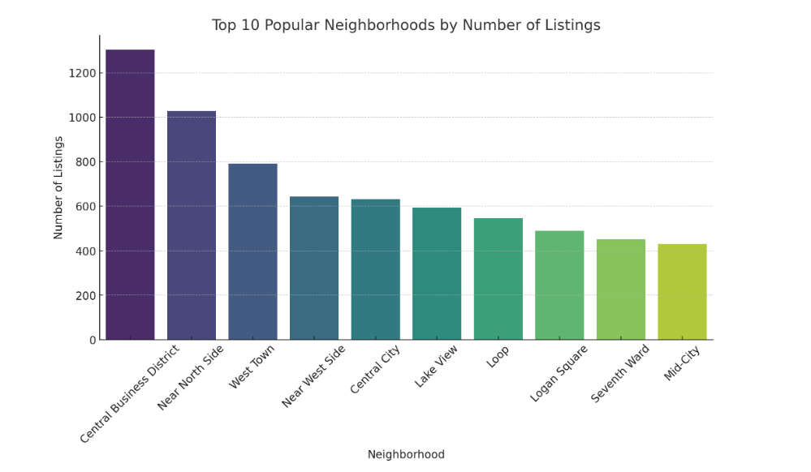

Pie Chart:-

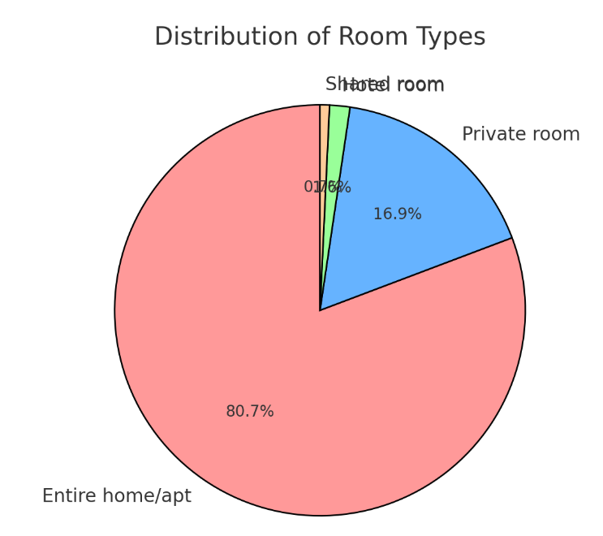

Property analysis:-

Understanding how different room types vary in pricing.

Distribution of listings across neighborhoods.

Box plot showing price variation across different room types-

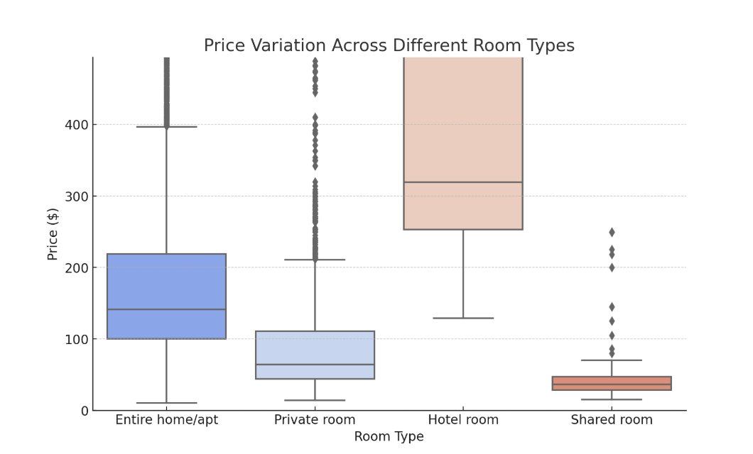

Histogram or density plot of listings across various neighborhoods-

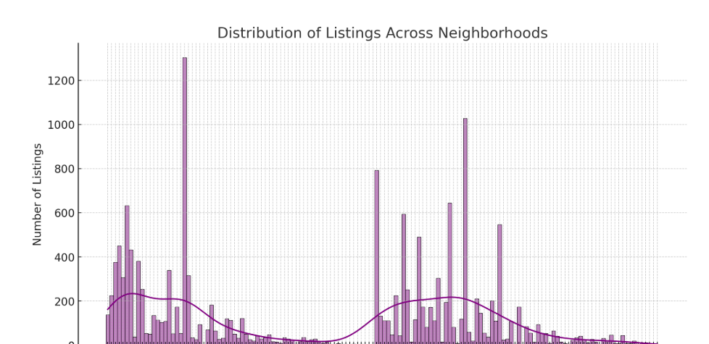

Pricing analysis:-

How pricing varies by location (neighborhood).

Relationship between price and number of reviews (to see if higher reviews lead to higher/lower prices).

Box plot of price variation across top neighborhoods-

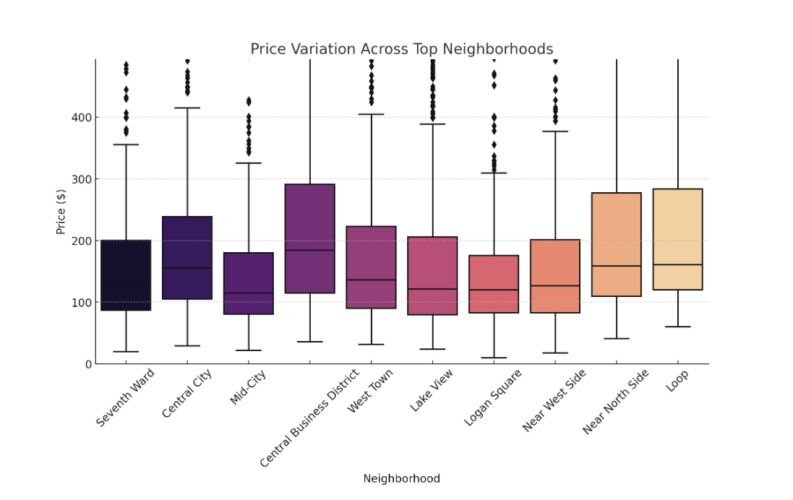

Host analysis:-

Difference in pricing and reviews between single-listing hosts and multi-listing hosts.

Bar chart comparing average price and average reviews between single-listing hosts and multi-listing hosts-

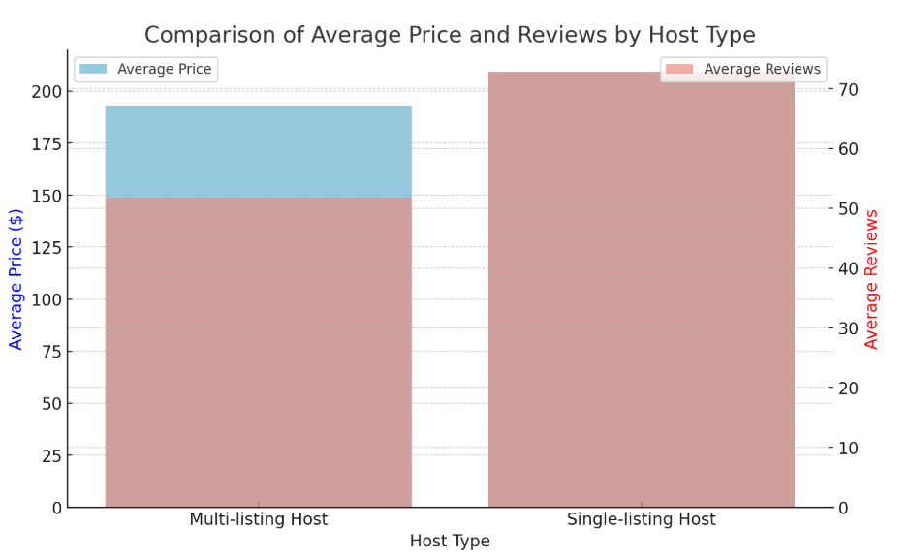

Final Dashboard design :

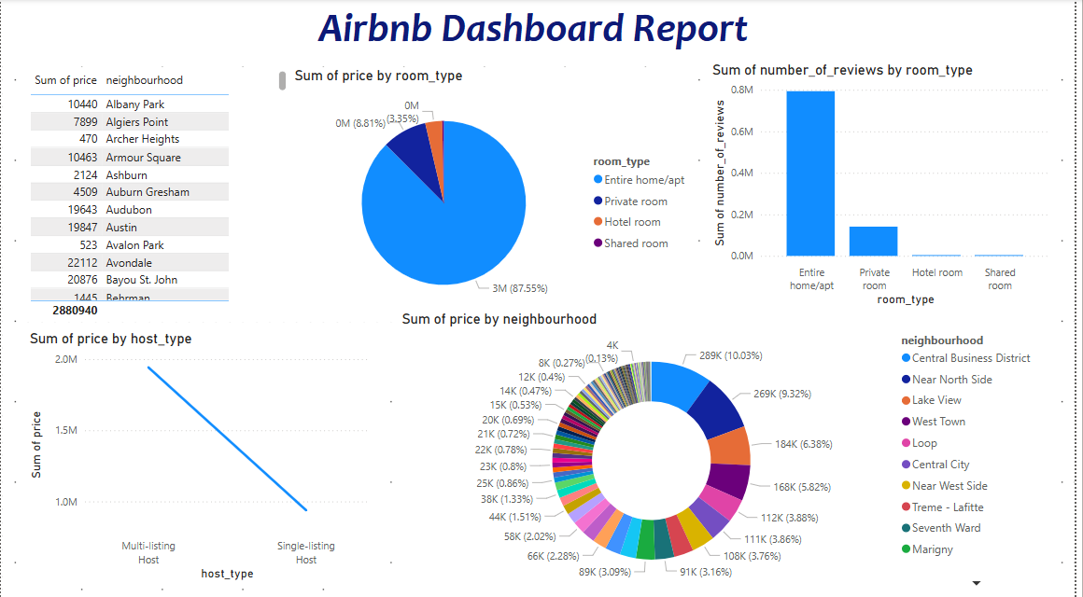

This is screenshot of designed dashboard.

From this design we find that -

This dashboard provides a comprehensive overview of Airbnb listings, focusing on price distribution, host types, reviews, and neighborhood insights.

Thank You